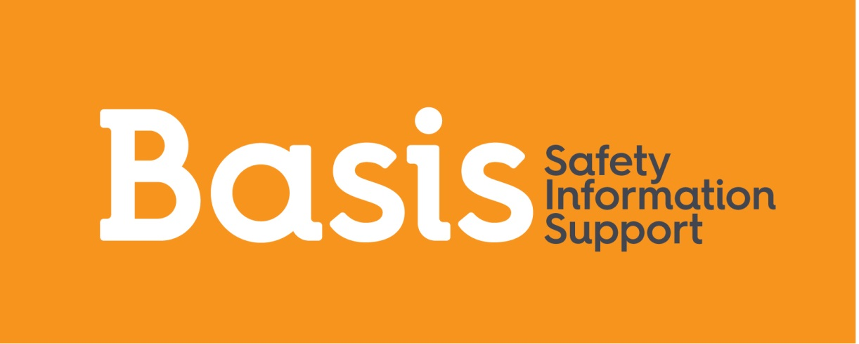

Person Specification

Job Title: | Early Intervention and Education Worker (Basis Young People’s Service)

EXPERIENCE
Essential |  | Desirable |  | How Assessed
- Minimum 3 years’ experience of direct work with young people.  - Experience of safeguarding children and young people.  - Experience of forming professional supportive relationships with young people.  - Proven experience of working with a wide range of other organisations and professionals.  - Experience of working both as part of a team and on own initiative.  - Experience in delivering group sessions.  - Experience of and commitment to managing performance and working to targets and goals |  | - 2 years’ experience of working with sexually exploited and abused young people.  - Experience of safeguarding children and young people from Child Sexual Abuse and Exploitation.  - Experience of developing sessions for use with young people.  - Experience and understanding of School Safeguarding Procedures  - Experience of delivering drop-in sessions.  - Experience of working with multicultural communities.  - Experience of working with young people with learning disabilities and marginalised communities.  - Experience of delivering training to professionals and young people.  - Knowledge of schools within the Leeds area. |  | Application Form  Interview

SKILLS / ABILITIES
Essential |  | Desirable |  | How Assessed
- Strong interpersonal skills and ability to communicate well.  - High levels of organisational skills and the ability to work independently to meet service delivery deadlines.  - Ability to advocate effectively for young people.  - Ability to discuss issues of a sensitive and sexual nature.  - Ability to develop good working relationships with staff from a range of agencies.  - Commitment to maintain client confidentiality.  - Ability to deal with difficult situations calmly, tactfully and responsibly.  - Ability to prioritise own work to meet deadlines and targets.  - Willingness to receive training to deliver training on child sexual exploitation and related matters to professionals and young people |  | - Ability to initiate and develop new projects.  - Ability to deliver training. |  | Application Form  Interview
KNOWLEDGE
Essential |  | Desirable |  | How Assessed
Knowledge of the issues faced by disadvantaged groups. Knowledge of the issues affecting sexually abused and exploited young people.  Knowledge of the key issues for those with additional needs in accessing services i.e. learning disabilities, cultural needs, etc.  Knowledge of Safeguarding procedures.  Awareness of key voluntary and statutory supporting agencies.  Awareness of sexual health matters.  Ability to work with Microsoft Office (spreadsheet, PowerPoint)  Ability to use a Client Management System and keep up to date, detailed case notes.  Clear, precise, report writing skills.  Understanding and commitment to the vision and values of Basis Young People’s Team and the Basis Sex Work Project. |  | Awareness of the issues around substance use. |  | Application Form  Interview
QUALIFICATIONS (Desirable)
No one specific qualification is required, but evidence of recent continuing professional development in a professional area relevant to the post will be required. This could be for example: Youth Work, Education, Children and Young People’s Sector, Women’s Sector. |  |  |  | Application Form  Certificates
TRAINING
Ability to recognise own training needs and commitment to personal development. |  |  |  | Application form  Interview
EQUALITY
An acceptance of and commitment to the organisation’s Equal Opportunities Policy. Commitment to anti-discriminatory practice and equal opportunities.  An ability to apply awareness of diversity issues to all areas of work. |  |  |  | Application form Interview
OTHER REQUIREMENTS
Confident and adaptable.  Able to work in a fast-moving environment with multiple deadlines.  Can travel extensively within the geographical area of work.  Can work some evenings and weekends if required  No contra-indications in personal background or criminal record indicating unsuitability to work with vulnerable young people. |  |  |  | Application Form  Eligibility Documentation  References  Criminal Record Check  Driving Licence

